# Progress Update 1

## Mockups

Wireframe have been prepared using Balsamiq, just because I’m more familiar with it and sketch would require more of learning curve. You may visit the following link and provide me with your feedback. If you already have a Balsamiq account or would like to collaborate with the design and workflow then please share your account details with so I may add you as a collaborator. Any and all sort of development is free for any critique.

[View design workflow](https://balsamiq.cloud/seu0gnm/p2funr0/r37C0?f=N4IgUiBcCMA0IDkpxAYWfAMhkAhHAsjgFo4DSUA2gLoC%2BQA%3D)

[Open in Balsamiq cloud](https://balsamiq.cloud/seu0gnm/p2funr0/r37C0?f=N4IgUiBcCMA0IDkpxAYWfAMhkAhHAsjgFo4DSUA2gLoC%2BQA%3D)

## KanBan Board

I’ve created a private repository on GitHub for sake of like development updates. You may visit it to view the current progress and update on the project. Please share your ID with me as well so I may add you to the collaborator. This will in turn give you the access to create/update the tickets with your progress and requirements as well, and feel free to do so. Here is snapshot for now since it can’t be viewed outside of being in the collaborator list.

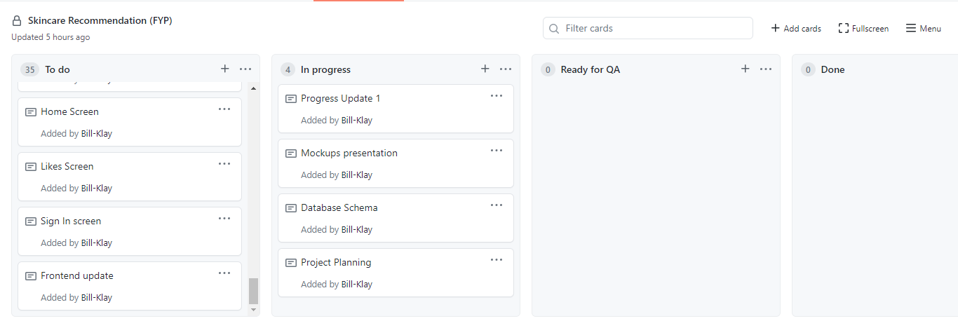

## Database Schema

Database schema is normalized and will be in consideration until the core development has began and requirements start to form up with more clarity. The scope for this section is the database for the server side, not for the frontend login/user data. If I did not understand the requirement for the fields in the database and their content, then please let me know. This is not the final form and your feedback in this regard will be much welcome for adding/removing any table and or column.

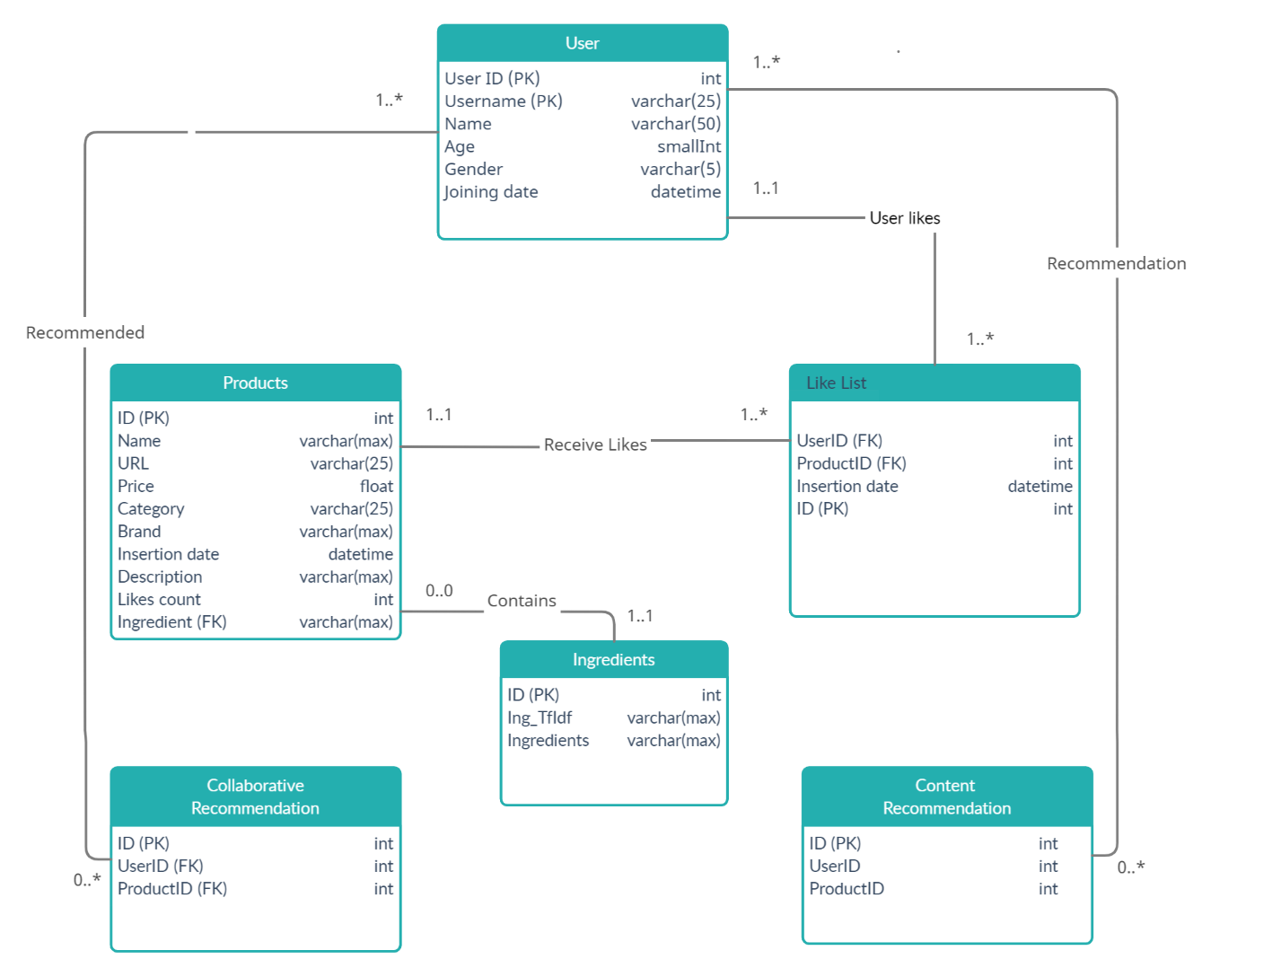

## Questions for review

Following a few questions for my understanding:

1. There won’t be any support for e-commerce? Buying and or selling
2. Will new items be added? If so, then what do you have in mind?
3. Currently a new user (with no prior history in the system) will be redirected to the home screen with a list of random items and brands, please refer to the mockup for better understanding.
4. Do we rely on image-based display for the application or textual? If images will be required we’ll be going with stock images for random products, and these are likely to repeat for multiple different products.
5. Collaborative data will be duplicated to MySQL from Firebase since login is being saved to the cloud, is this fine or am I missing something on my behalf?
6. User data that will be required as is visible on the profile screen in the wireframes. Any other feature that you might think is valuable or redundant is open for discussion.